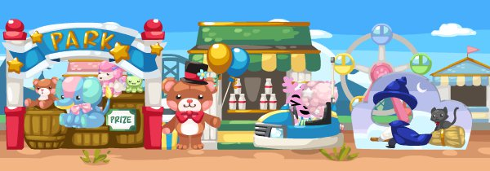
English Language
中國語文

數學

Interactive games are categorized by Key Stages (Key Stage 1, 2 and 3) and then by Skills (Listening, Reading, Writing and Speaking)

There are 3 pages for the “English Land”:
- Primary 1 – Primary 3 (Listening, Reading, Writing and Speaking)
- Primary 4 – Primary 6 (Listening, Reading, Writing and Speaking)
- Secondary 1 – Secondary 3 (Listening, Reading, Writing and Speaking)

The idea is to use a roller coaster to chain up the tasks. Each row contains 4 to 5 tasks (depends on the design)
The idea is borrowed from HKEdCity:
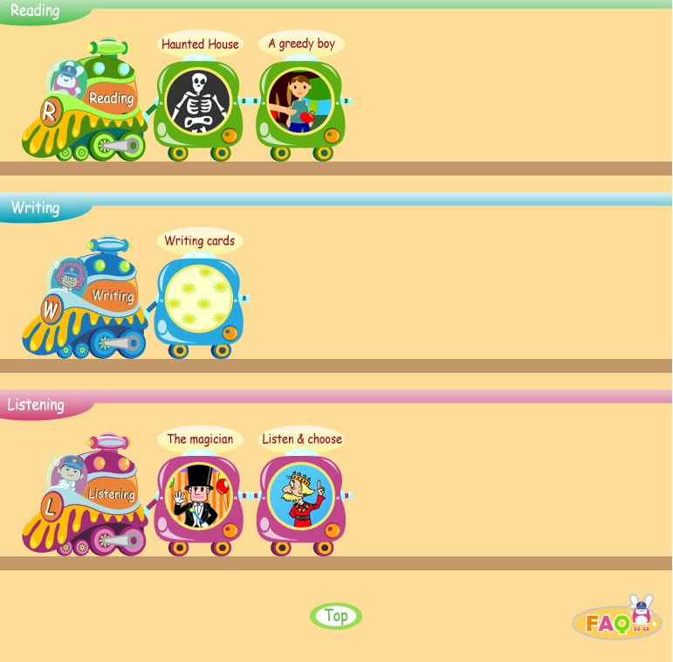

Welcome to English Land

Primary 1 – Primary 3
Listening
Dos and Don'ts | Going for a Picnic-1 Going to the Zoo | Going for a Picnic-2 At the Supermarket | Guessing Animals-Which Animal Is It | Happy to Read Aloud
King Kong and Ken | Listen to My Voice-1 Pat is Home | Listen to My Voice-2 My New Timetable | Packing Up-Put the Toys Back | Playing with Sounds-Listen and Choose
Saving Princess Nancy | Signs & Instructions-Be a Nice Kid | Student Cards 1 | Student Cards 2
Reading
A Greedy Boy | A Story About Bobby-Bobby Needs Help | Birthday Angel 1 | Birthday Angel 2 Letters to Birthday Angel | Birthday Angel 3 Letter Box
Birthday Angel 4 Writing Letters | Book Covers 1 Knowing More About Books | Book Covers 2 Learning About Book Covers | Card Writing 1 Writing Cards | Card Writing 2 Sending Miss Chan a Card
Card Writing 3 Tom's Halloween Party | Card Writing 4 Mike's Christmas Party | Choosing Presents | Dos and Don'ts | Fun with Riddles 1
Fun with Riddles 2 | Happy to Read Aloud-The Magician | Haunted House | King Kong and Ken | Knowing More About Clothes
Packing Up-Put the Toys Back | Playing with Sounds-Listen and Choose | Reading the Book Cover-Lost in the Forest I | Saving Princess Nancy | Signs & Instructions-Be a Nice Kid
Stories of Animals | Student Cards 1 | Student Cards 2
Writing
Birthday Angel 1 | Birthday Angel 2 Letters to Birthday Angel | Birthday Angel 3 Letter Box | Birthday Angel 4 Writing Letters | Card Writing 1 Writing Cards
Card Writing 2 Sending Miss Chan a Card | Card Writing 3 Tom's Halloween Party | Card Writing 4 Mike's Christmas Party | Student Cards 2
Speaking
Happy to Read Aloud | King Kong and Ken

Welcome to English Land

Primary 4 – Primary 6
Listening
Be a Good Cook-Cook Like Jimmy | Listen to Instructions | Lovely Letter Sounds-1 A Lesson for Jack | Lovely Letter Sounds-2 Selfish Sandy | More About Sounds-Peter the Acrobat
The Time Tunnel-1 Back to 1975 | The Time Tunnel-2 Back to the Present | Travelling Abroad | Yummy, Yummy, Let's Eat-1 Food Stories | Yummy, Yummy, Let's Eat-2 Lunch Today
Reading
A Lesson for Jack | Be a Good Cook-Cook Like Jimmy | Letter Writing 1 A Letter to a Friend | Letter Writing 2 What is Different | Letter Writing 3 A Letter to the Principal
Lovely Letter Sounds-1 A Lesson for Jack | Lovely Letter Sounds-2 Selfish Sandy | More About Sounds-Peter the Acrobat | Siu Ming Learned a Lesson | The Time Tunnel-1 Back to 1975
The Time Tunnel-2 Back to the Present | Vehicle’s Riddles | Yummy, Yummy, Let's Eat-1 Food Stories | Yummy, Yummy, Let's Eat-2 Lunch Today
Writing
Letter Writing 1 A Letter to a Friend | Letter Writing 2 What is Different | Letter Writing 3 A Letter to the Principal
Speaking
Listen to Instructions-Mother’s Instructions | Yummy, Yummy, Let's Eat-1 Food Stories | Yummy, Yummy, Let's Eat-2 Lunch Today

Welcome to English Land

Secondary 1 – Secondary 3
Listening
A Study Tour to New Zealand | For Your Eyes Only | Interviewing Mr Hall | Mind Your Own Words-1 Listen Beyond the Surface | Mind Your Own Words-2 Euphemism Quiz
Step It Up | Travelling to Australia-1 Attractions in Australia | Travelling to Australia-2 Stephen's Itinerary
Reading
Cross-country Hike | Detective Academy-1 Eye Spy | Detective Academy-2 Secret Codes | Detective Academy-3 The Final Challenge | Exploring Hong Kong-1 Attractions in Hong Kong
Exploring Hong Kong-2 Planning an Itinerary | Finding My Way to Mongkok | Finding Poemland | For Your Eyes Only | Looking Up Words in Dictionaries
Mind Your Own Words-1 Listen Beyond the Surface | Mind Your Own Words-2 Euphemism Quiz | Note-taking-1 Common Symbols for Note-taking | Note-taking-2 Abbreviations in Note-taking | Note-taking-3 Forming Abbreviations
Note-taking-4 Decoding Messages from Notes Abbreviations | Reading for Main Ideas-1 | Reading for Main Ideas-2 | Reading for Main Ideas-3
Spotting the Offender-1 Big Words to Learn | Spotting the Offender-2 The X-Files | Step It Up | Travelling to Australia-1 Attractions in Australia | Travelling to Australia-2 Stephen's Itinerary
Travelling to Australia-3 Facts about Australia
Writing
Note-taking-1 Common Symbols for Note-taking | Note-taking-2 Abbreviations in Note-taking | Note-taking-3 Forming Abbreviations | Note-taking-4 Decoding Messages from Notes Abbreviations | Reading for Main Ideas-3
Step It Up | Travelling to Australia-3 Facts about Australia
Speaking
Finding Poemland | Interviewing Mr Hall

